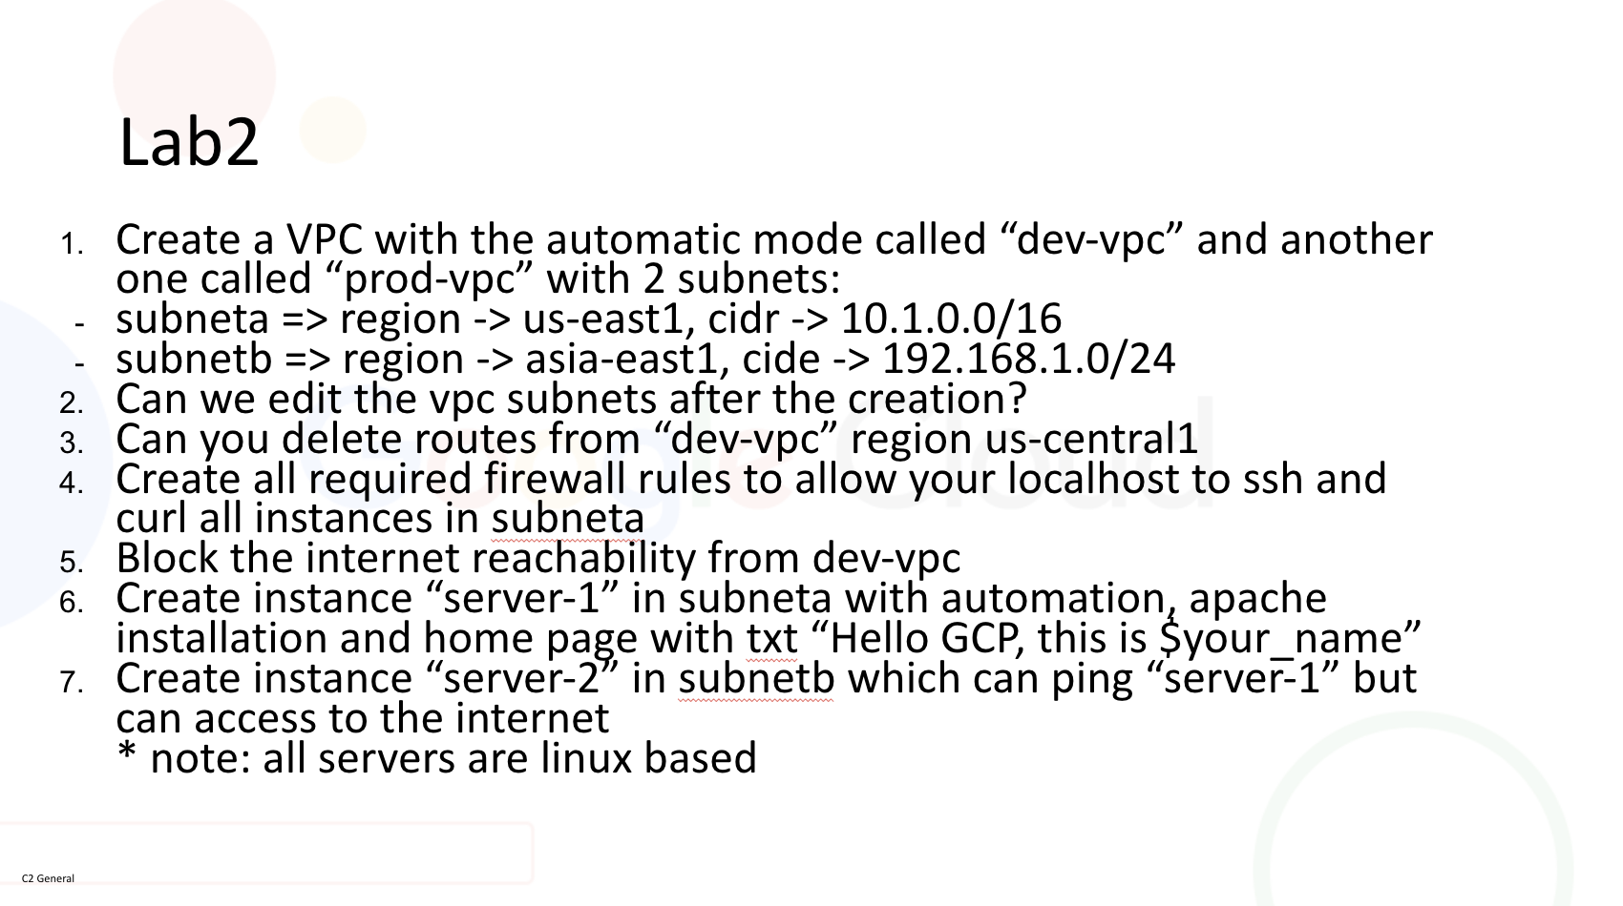
Name: Hadi Lotfy
Host: Andrew Anter
Project Name: hadi-lotfy-project
Project Number: 96418353483
Project ID: hadi-lotfy-project

q. what about region “us-east-7” that exists only in the default vpc subnets but cannot create a subnet there in my vpc ?
- Create two VPCs
  - Create a VPC with the automatic mode called “dev-vpc”
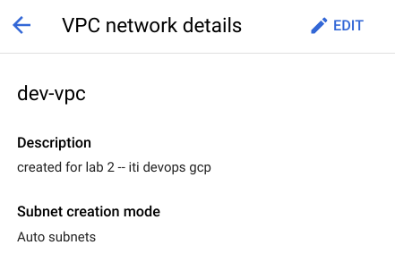

  - and another one called “prod-vpc” with 2 subnets:
    - subnet-a ==> region ( us-east1 ), CIDR (10.1.0.0/16)
    - subnet-b ==> region ( asia-east1 ), CIDR (192.168.1.0/24)

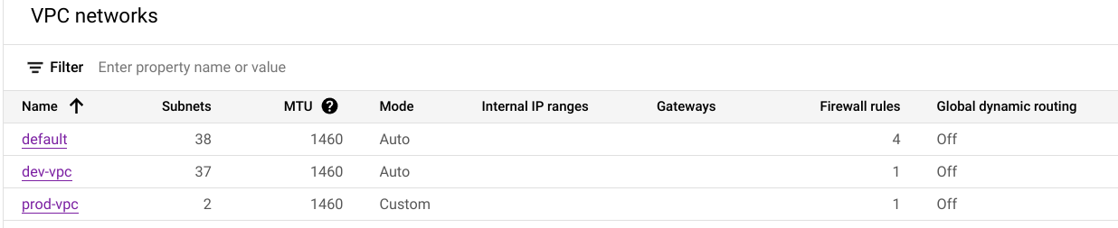

- Can we edit the vpc subnets after creation ?
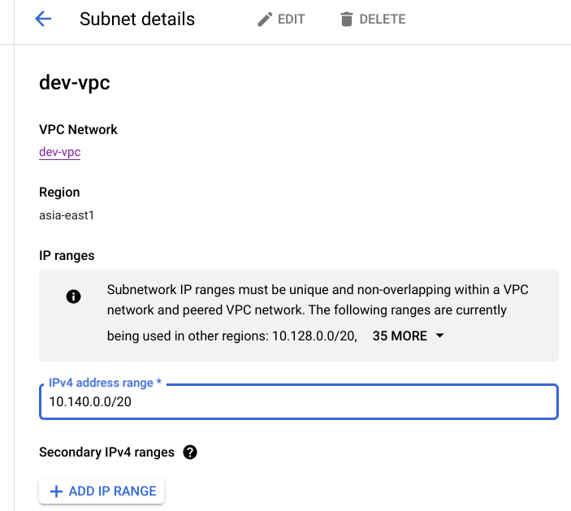
Yes we can edit it, but the name, vpc, and region cannot be changed (at least from the console)

- Can you delete routes from “dev-vpc” region us-central1
I cannot delete subnet routes
(but can delete static routes freely that are children of the vpc not the subnet.)

- Create all required firewall rules to allow your localhost to ssh and curl all instances in subnet-a.

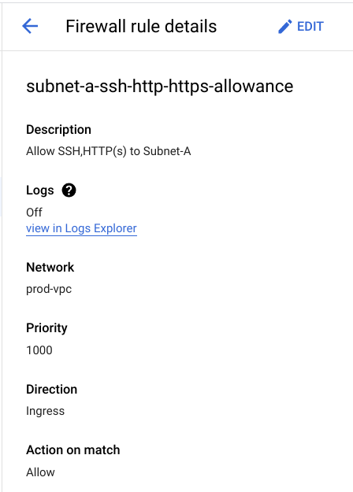
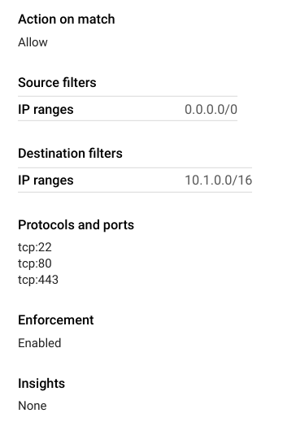
- Block the internet reachability from dev-vpc
using a firewall rule to block internet reachablity.
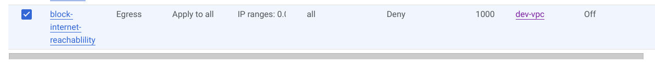
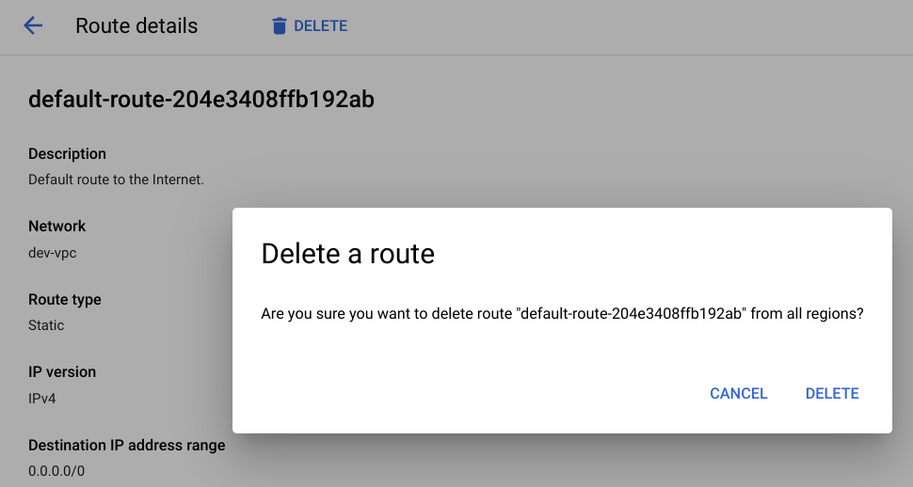
Another way of doing so is by deleting the “default internet route from the vpc.

- Create instance “server-1” in subnet-a with automation for apache installation and home page with txt “Hello GCP, this is “Hadi Lotfy”.

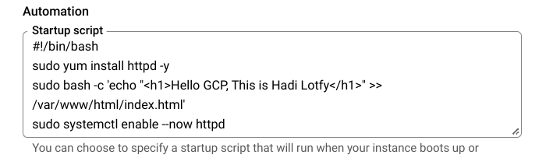
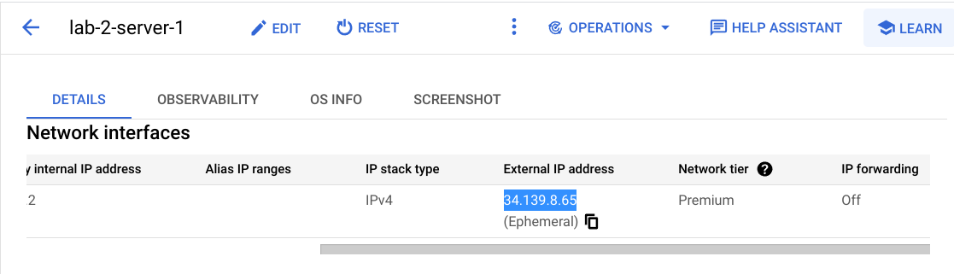


- Create instance “server-2” in subnet-b which can ping “server-1” but can not access to the internet.

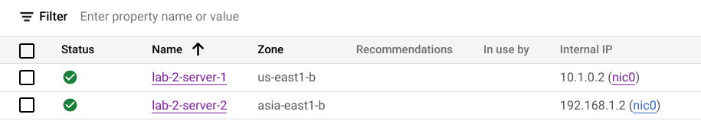
Fire wall rules to prevent internet access and to allow ping to subnet-a instances.

